Pre-K 3 Schedule
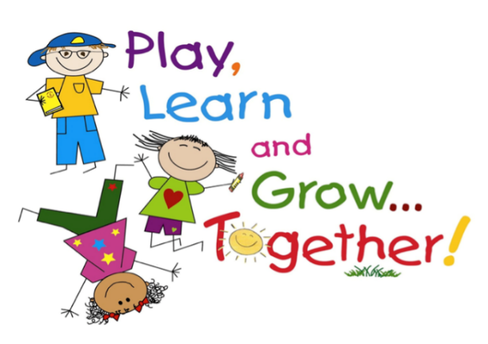
Under the direction of a great team of teachers using a Montessori-style approach to learning, students will explore new ideas, experience hands on learning, and learn to work with others.
The children will spend most of their time playing and working with materials or other children. They will have access to various activities throughout the day. From assorted building blocks and other construction materials; props for pretend play; picture books; paints and other art materials; and table toys such as matching games, pegboards, and puzzles, the children will have loads of fun playing and learning in a set of rooms designed just for them!
Our young learners will learn numbers and the alphabet in the context of their everyday experiences. The natural world of plants and animals and meaningful activities like cooking, cleaning, or serving snacks provide the basis for learning activities. The children will work on projects and have long periods of time (at least one hour) to play and explore each day.
The students will enjoy exploring and exercising in our new Sensory Zone. With bright colors and stimulating activities such as our new sensory path, exercise equipment, games, and toys, the children will love playing in the new Sensory Zone.
After play time, teachers will read books to children individually or in group story time. Each child will have fun playing with their friends and teachers.
Class will be limited to 8-10 students ages 3-4. We hope to add Kindergarten next year.
Children must be potty-trained. There will be a short nap time provided
Students should bring a sack lunch, but no foods to heat up. Students should also bring a change of clothes in case of an accident.

Dates: Wednesday - 9/4-11/20/19 and 1/22-4/15/20
Time: 9:15-2:45 pm
Cost: $1500
Teachers: Leigh Ann Whitman, Team Leader
Api Wales, Co-Teacher; Spanish Instruction
Debby Jasinski, Art/Movement Teacher

