Kindergarten Schedule 2022-23
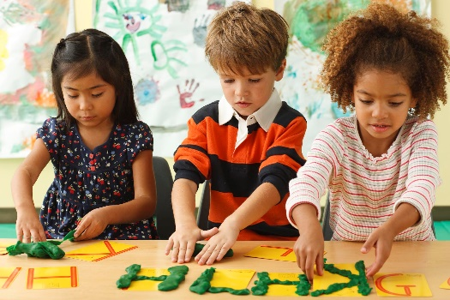
Under the direction of a great teacher using a Montessori-style approach to learning, students will explore new ideas, experience hands-on learning, and learn to work with others. Though some think of kindergarten as a year of play, in actuality kindergartners work hard and learn a lot in a very short time. Kindergarten gives children the opportunity to grow and develop through play — the way children learn best. It is a time for children to expand their love of learning, build knowledge, develop their ability to get along with others, and explore ways of reaching out to the world.

The children will play and work with materials such as magnifying glasses, puzzles, magnets, and more. Children will explore centers filled with assorted building blocks and other construction materials; props for pretend play; picture books; paints and other art materials; and table toys such as matching games, pegboards, and puzzles, the children will have loads of fun playing and learning in a set of rooms designed just for them!

Students who are ready will advance in reading, phonics, math, and science. Teachers will provide activities for both non-readers and advancing readers. Many activities will revolve around exploring ideas, concepts, and new materials. Art activities will focus on creativity and exploring new techniques, tools, and colors. Spanish will be introduced at an age-appropriate level.
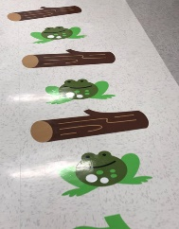
The students will enjoy exploring and exercising in the Sensory Zone. With bright colors and stimulating activities such as our new sensory path, exercise equipment, games, and toys, the children will love playing in the Sensory Zone.
After play time, teachers will read books to children in group story time.
Class will be limited to 10 students ages 5-6. Students should bring a sack lunch, but no foods to heat up. Students should also bring a change of clothes in case of an accident.
Some parents will use a Kindergarten curriculum at home. Others may use HEP’s Kindergarten program for an enrichment day or a play school experience. It is up to the individual family to make this decision. Texas law does not require a child to attend public school until age 6.
Dates: Mondays – Fall 8/22-11/14 (Labor Day 9/5 closed) and Fall 1/16-4/10/23
Thursdays – Fall 9/1-11/17/22 and Spring 1/19-4/13/23
Time: 9:15-2:45 pm (no after class babysitting is available)
Cost: $1300 Monday OR Thursday
$2400 Monday & Thursday (2-day discount)
Lead Teacher: Tamahara Floyd
Art Teacher: Debby Jasinski
Spanish Teacher: Alejandra Guerra-Moxey

