**HEP TX Summer 2025 Schedule**



**College Prep Courses**

**STEAM CAMP (Science, Technology, Engineering, Art, Math)**

**Grades Rising First Grade – Eighth Grade**

Oceanography STEAM Camp

DIVE INTO STEAM to explore the earth’s oceans. As oceanographers, students will learn about waves, salt- water density, blubber insulation, submersibles, buoyancy and density, and shore erosion. Students will also explore pollution solutions related to plastics in the ocean. On Friday, there will be an optional family field trip to Galveston Island’s Texas A & M Campus for a “Sea Turtle Biology/Ecology and Sea Turtle Nesting” experience.

Students will rotate through several appropriate age sessions each day. With a variety of fun and engaging activities, students will explore science, technology, engineering, art, and math. From cool science experiments to exciting engineering projects, students will love the science, engineering, and technology sessions. During the art sessions, students will tackle challenging projects that relate to the topics of the day.

**WHY STEAM CAMP?** Students from rising first graders to rising eighth graders will find these camps exciting and stimulating. Enrichment experiences in the STEAM fields will ignite the kind of curiosity that often leads to a fulfilling and meaningful work life. A two-year study of nearly 1600 middle school students across the country revealed that “students who once participated in science summer camps were more likely to later report a career interest in the science and engineering fields.” It’s clear that enrolling your child in a STEAM focused camp is an ideal way to provide more options as they start considering their paths through high school, college and beyond.

**Dates:** June 16-19; **Optional** Field Trip on Friday June 20 to Galveston’s Texas A & M Campus for a 2-hour Sea Turtle experience.

**Time:** 9:00 am - 12:30 pm; Friday’s time TBA

**Cost:** Early price: $99; After 4/13: $115; Field Trip Cost: $8 per person.

**Faculty:** The Grades 3-8 Teachers are Sue Rothberg, Tara Saxon, and Debby Jasinski. The Grades 1-2 Teachers are Elaine McWhirter and Debby Jasinski.

# We reserve the right to change the description of the camp pending the field trip costs or teacher changes.

# Adult Homeschool Workshops

**Homeschooling 101 Seminar –**This free seminar will discuss the legalities of homeschooling, how to choose the right curriculum, and how to get started and organized.  There will be a question and answer period.

**NO** RESERVATIONS REQUIRED.

**Cost:**FREE

**Instructor:**   Joanne Juren, B.A., M. Ed.

**Date:**May 15 – 10:00-11:30 am

**Date:** August 1 – 1:00-2:30 pm

**_______________________________________________**

**Art Workshops**

**Prerequisite for Summer Art Classes:**

Anyone with any skill level and/or experience with art is welcome! The one and only overall requirement is to bring a sense of dedication and passion to learning and enhancing your craft every day. Each course will begin with a quick introduction and refresher on drawing fundamentals and basics.

Grades: 6-12. We must have three in a class to make.

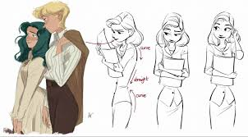

**Storytelling Through Character Design** - **Emily Boone** - What’s a story without characters to tell it? Here, students will learn how to visualize and create a fleshed-out character in their head and onto paper, utilizing techniques to enhance silhouette with shape language, how color can affect an audience's perception of said character, and more. Additionally, the differences between characters designed for animation, 2D, or 3D, comics, and more will be assessed to help decide in what direction students may want to take their ideas.

**Time**: July 14-17; 10 am -1 pm

**Cost:** $175

**Digital Illustration** – **Emily Boone** - Exploring digital art programs, learning shortcuts, and applying basic drawing fundamentals in order to create finished pieces of art ready for display and pieces for future portfolios, students will go through the process from beginning to finish to be able to complete a full illustration with the drawing device of their choice by properly navigating through digital drawing programs. Differences between different color profiles, DPI’s, and more to learn the process of creating art for web or print will be discussed and explored as well to teach maximum efficiency and get a peek into the professional art world. **Required materials - Any digital device / tablet to access drawing programs on and to draw.**

**Time**: July 21-24; 10:00 – 1:00 pm

**Cost:** $175

**I****ntroduction to Storyboarding** – **Emily Boone** - Almost every piece of visual media, such as movies, tv shows, commercials, and video games, begin the process with storyboards. In this course, students will learn many different tricks to be able to quickly sketch out and board a scene, focusing on composition and readability rather than detail all in order to effectively communicate the idea of a story, possibly to a director or whoever may be requiring a storyboard for their project.

**Instructor:** Emily Boone

**Time:** July 28-31; 10:00 – 1:00 pm

**Cost:** $175



**Introduction to the Comic World** – **Emily Boone** - This class is designed for anyone interested in delving into the comics industry, whether to make full on graphic novels or serially published comics. Student will learn the differences between working independently or alongside a publisher and with an editor. While going through the process from thumbnails to finish, students will learn the importance composition plays on an overall comic page, both outside and within the panels and properly utilizing word balloon placements all while avoiding tangents to enhance readability.

**Time:**Aug 4-7; 10am - 1pm

**Cost:** $175

**_______________________________________________**

**College Prep Courses**

We recommend the parents and student both take this course.

**Getting Ready for High School and College Seminar (Joanne Juren) –** If you have a student in 7th grade or above, then this class is for you. During this informative seminar, Joanne Juren will discuss many topics pertinent to students just entering high school. Topics include goal setting, course guidelines from 7th – 12th grade, the 4-year plan, high school transcript, extracurricular courses and activities, job co-ops, testing for high school and college, scholarships, and many more! Each parent will create a 4-year plan for his or her student(s). There will be plenty of time for questions and answers! With one paid adult, the student may attend free of charge. Reservations required. The *Getting Ready for High School and College* book is available at the special rate of $20.

**Cost:** $45; $65 with the book.

**Date:** Thursday, May 15

**Time**: 1-4 pm

**HEPTX.com**

**Executive Functioning Skills**

**Is this your child?--- Chronically disorganized? Always Late? Unmotivated? Lacks self-control?**

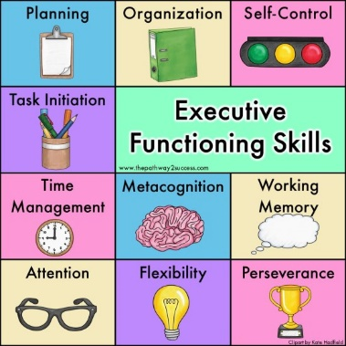

**Executive Functioning Skills** –Helping students develop Executive Function (EF) strategies – goal setting, cognitive flexibility, organizing and prioritizing, memorizing, self-checking and monitoring – can be the difference between success and failure. Targeting students in grades 6-12, this 4-day workshop covers motivation, memorization techniques, test-taking strategies, note taking, time management, goal setting, focusing, and controlling stress. Using a variety of interesting lessons, students will better understand how to tackle projects and learn how to learn! This course is highly recommended for students who want to excel academically and be better prepared to solve problems.

**Instructor:** Joanne Juren

**Cost:** $190 (includes $35 book and materials)

**Dates:** July 28 – 31; 1-3 pm (2 hours per day)

# Language Arts

# 

**Reading Camp: Syllables Solve the Mystery! (Grades 3-5) -** Vowels can be so confusing! How can students know what sounds they make in larger, unknown words? Syllables solve the mystery! In this engaging upper elementary camp, students will learn the six major syllable types and how to use them when reading unknown words. Learning the clues to identify syllable patterns and apply them when reading new words empowers students to become confident, life-long readers! Bring a folder with notebook paper and a pencil.

**This camp is for students who are fluent in basic reading skills and are ready to read multi-syllable words.

**Instructor:** Sarah Silva

**Cost:** $150

**Dates:** June 9-13; 9:00-10:30 am

](https://heptx.com/wp-content/uploads/2018/01/ms-writing-fun.jpg)

**Writing Camp: WRITE! WRITE! WRITE! (Grades 3-5) -** In this exciting elementary camp for grades 3-5, students will write, write, and write! First, they will practice the basics of paragraph organization and will write a descriptive narrative. Then, students will explore their creative side through different types of poetry and write their own poem. On the last day, the group will work cooperatively and write a fun story together! Bring a spiral notebook and a pencil.   
**Instructor:** Sarah Silva

**Cost:** $150

**Dates:** June 9-13; 10:45-12:15 pm

**Middle School Writing Workshop for Grades 6-8 -** Popcorn, a movie, and lots of laughs...this is the perfect camp for your middle school student.During middle school, it is important for students to develop strong writing skills.  By understanding the writing process, students will better understand how to do writing assignments. During this exciting and fun four-day workshop, students will focus on the paragraph format and write different types of paragraphs including descriptive, narrative, comparison, and literary analysis. Using high- interest activities and literature, Mrs. Juren will excite even the most reluctant writer. This course is a must before students attempt the five-paragraph essay and high school. Class is limited to 15 students.

**Instructor:** Joanne Juren

**Cost:** $175

**Dates:** July 28-31; 10:00-11:30 am

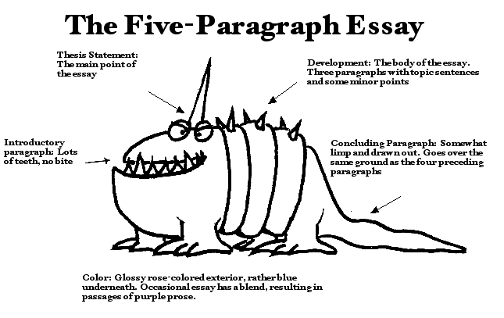**Five-Paragraph Essay Writing Workshop -** Don’t let the beast scare you! This four-day workshop for grades 8-12 will teach the basics of five-paragraph essay writing and help you tame the beast! Students will learn the basic structure of the essay through a visual drawing. They will practice each part of the essay and write one essay. This easy and interesting presentation will help even the “grumpiest” writer learn that writing can be easily mastered when given the proper tools! Mastery of the five-paragraph essay will help students earn success in both high school and college. Absolutely no one younger than 8th grade may attend this accelerated presentation. This course is not recommended for students who struggle with English or who do not have mastery of basic paragraph writing. The *Writing Handbook* is required for the workshop and may be purchased at the HEP Bookstore. The class size is limited to 15 students. New students planning on attending HEP’s high school classes are encouraged to take this course. Students will write in class and at home each night. On the last day, students will finish the rough draft. The instructor will critique each section during the week so that the student will not have any homework after the last day of class.

**Instructor:** Laura Coker-Garcia

**Cost:** $175

**Dates:** August 4-7; 1:00 – 3:00 pm

**Research Workshop -** One of the biggest problems students face in the upper grades and college is researching ideas for writing. Often, the student does not know where to look, how to phrase the research inquiries, and how to then place the “research” into the paper. Students will be introduced to AI and learn how to use it without plagiarizing. Students should understand the MLA format and five-paragraph essays. The book The Writing Handbook is required. Recommended for grades 10 and up. Class is limited to 15 students. A laptop (preferable) or smart phone is required to conduct research in class. **Note:** Students will NOT write a paper in these 4 days.

**Instructor:** Joanne Juren

**Cost:**  $195

**Dates:** August 4-7; 1:00-3:00 pm

# Image result for be verbsNo Be Verbs Workshop – This 2-hour workshop will help both the student and parent better understand the concept of elevated writing by focusing on removing “to be” verbs, the verb “to have,” and “dead words” on the No-No list. Students and parents will practice elevating sentences during the workshop. Instructor: Joanne Juren Cost: $35 student; $15 parent Date: August 7; 10-noon

**HEPTX.COM**

**Math**

 **Algebra 1 Refresher** – Entering Algebra 2 or Geometry this fall? Mrs. Red will review important concepts from Algebra 1 necessary for success in Algebra 2 and Geometry. This short camp will refresh those Algebra 1 skills to help you do better in your next class.

**Instructor:** Cheryl Red

**Cost:** $150

**Dates:** August 4-7; 9:30 – 11:30

**Speech**

# 

**High School Speech (Grades 9-12) –**This two-week high school course (grades 9-12) is dedicated to teaching public speaking skills. Taught by an experienced speech and debate coach, this class will prepare even the shy student to be able to speak in public situations. Students will present a variety of impromptu as well as prepared speeches. Students will also learn how to constructively critique other students and how to accept constructive critique. Speech counts as ½-credit on the high school transcript. **Textbook:** BJU’s *Sound Speech* – we have a classroom set. Class is limited to 10 students. **Instructor:** Allison Naumann

**Cost:** $399

**Dates:** June 9-19; Monday-Thursday each week; 9:00 - Noon

The official HEP of Texas, Inc. registration form must be filled out completely, including the emergency information, health information, and parent release. No registration is considered official until payment for classes has been made. All summer courses must be paid for at the time of registration.

**New Student Fee:** $25 for the summer camps. If a student is already enrolled for the 2024-25 school year and has paid the full $100 registration fee, he does not need to pay for the summer.

Registration is first come, first served. HEP of Texas, Inc. reserves the right to limit enrollment and to change times or dates and teachers if needed, or even cancel camps, classes, and/or workshops due to circumstances not under our control. Camps are open to home school, public school, and private school students.

Camps are grouped by subject. The instructors, dates, times, costs, pre-requisites, supplies, and descriptions are listed for each camp, class, and workshop. All course descriptions listed are the intellectual property of HEP of Texas, Inc. and are protected by copyright law, 1997-2024. These courses are copyrighted, and all intellectual properties related to these courses belong to Home Education Partnership of Texas, Inc. and Joanne E. Juren

**STANDARDIZED TESTING**

IOWA TESTING is scheduled for Tuesday/Wednesday May 13 and 14 at HEP TX!

More details are available on the separate handout or at HEPTX.com

**SUMMER HOURS**



Monday-Thursday – 10-3 pm.

Fridays: 10-3 pm when camps or classes are in session. No administrative staff is on duty on Fridays.

SCHOOL CLOSURE: June 30 – July 11 for vacation. We will reopen on Monday, July 14 at 10:00 am.